1. Surface electromyography (sEMG), as we performed, measures the activity of many motor unit action potentials. Is it possible to measure action potentials in individual motor units with electrophysiology? If so, what would we need to change about our experimental set-up to accomplish this?

**A**: No, because the electrodes are surface mounted and detects multiple motor unit action potentials as a whole, as such are not able to detect specific action potentials. To be able to detect action potentials in individual motor units, instead of using a sEMG, a needle electrode is required.

1. Describe the relationship you observed between EMG and load force in experiment 3 (1-2 sentences).

**A**: EMG is positively correlated with the load force.

1. Based on your results, would you be able to use sEMG to “decode” the weight of the load in the hand? What, if any, limitations would this decoder have? (Hint: Is there a difference between the muscle activity when you grip something while keeping your hand still vs. while moving?)

**A**: Yes, because of the positive correlation between EMG and load force as more muscles are activated to sustain the load, it is possible to decode the weight of the load, but it won’t be as accurate. Moreover, the muscle groups involved in gripping when the hand is still and while its moving are different.

1. Consider the variability across evoked muscle twitches in experiment 1. What are the largest sources of variability in your measurement? How could you improve your experiment to reduce this variability? **Note**: Be sure to think carefully about what things actually changed in your setup across the different measurements you made!

**A**: A large source of variability is the improper placement of the stimulation electrodes over the effected muscle as well as the baseline resting state and placement of the hand over the pressure sensor. A possible improvement is to use a marker to mark the location of the muscle in order to more accurately place the electrode. Moreover an arm harness might be useful to keep the hand in a set position and the pressure sensor glued in place, improving the baseline resting state and placement of the hand over the sensor.

1. 5. Based on the Size Principle, what would you expect the relationship between contraction time and twitch force to be? (1 sentence) In your stimulation experiments, what was the relationship between stimulation amplitude and contraction time? (1 sentence) What hypothesis does this support about how electrical stimulation recruits motor units?

**A**: Contraction time is positively correlated with twitch force, as the more intense the signal, the larger motor neurons are recruited, and more force is generated at the same time. In our results, there is a positive correlation between amplitude and contraction time, as at higher stimulation, the amplitude rises at roughly the same time. This supports the hypothesis that smaller motor neurons are recruited first in response to excitatory signals, before larger ones, as the smaller ones are more sensitive to synaptic current than the larger ones.

1. 6. A common problem observed in Functional Electrical Stimulation (FES) for evoking muscle activity is rapid fatigue of muscles. Based on your results, explain why.

**A**: Muscle fatigue from evoking muscle activity is a result of overuse of the fast-contracting muscle fibers, which are stimulated and use more energy.

7.

* + 1. Based on what we’ve learned about muscle twitch recruitment dynamics, in experiment 2 we expect to see that average twitch amplitude (INCREASES, DECREASES) as stimulus frequency increases, and average overall force (INCREASES, DECREASES) with stimulus frequency. (note: you may have seen different relationships in your data.)

**A**: We expect the average twitch amplitude to increase overall with increasing stimulus frequency. The average overall force, similarly increases overall with increasing stimulus frequency.

* 1. Briefly (2-3 sentences) explain why.

**A**: This is because a second (or more) muscle contraction close to the first will sum the force generated, but this won’t happen if it occurs during the absolute refractory period of the first. In other words, at far apart stimulations, no summation occurs, but at closer paced stimulus, periodically varied force at the stimulus frequency (unfused tetanus) occurs. And eventually, high frequency stimulus results in a smooth force (fused tetanus).

1. Append the underlined figures from each experiment generated by running the data analysis scripts to your comprehension questions.

**A**:

**Experiment 1**

**Raw Trial-Sorted Force Profiles**

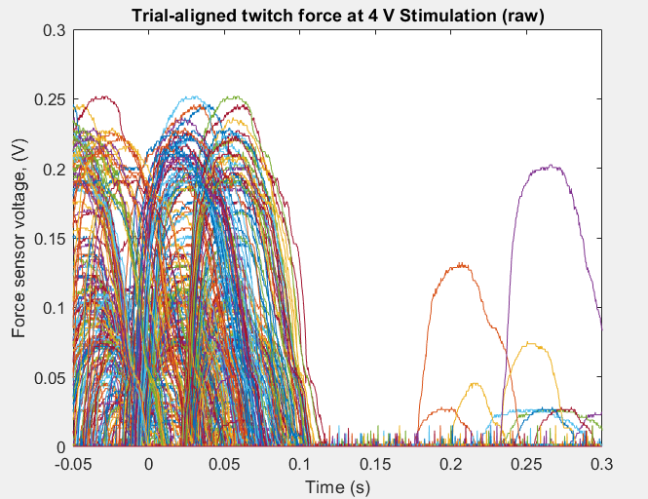

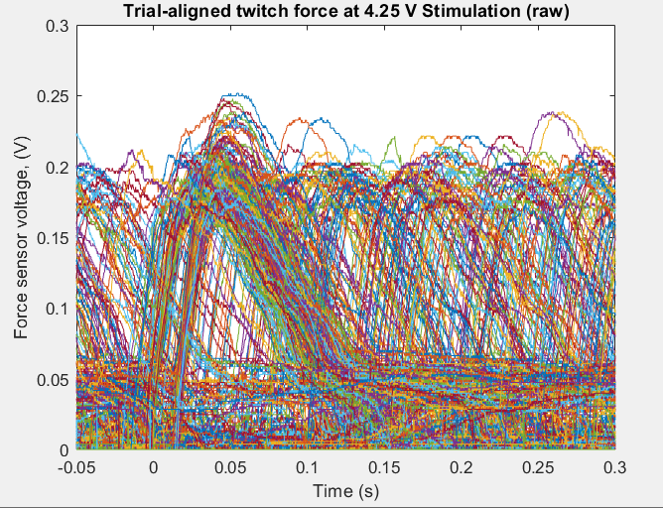

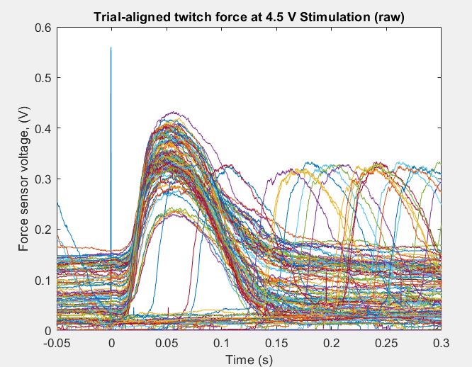

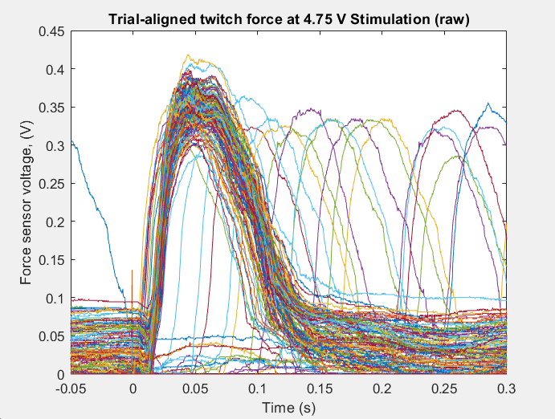

**Trial-Averaged Force Profiles**

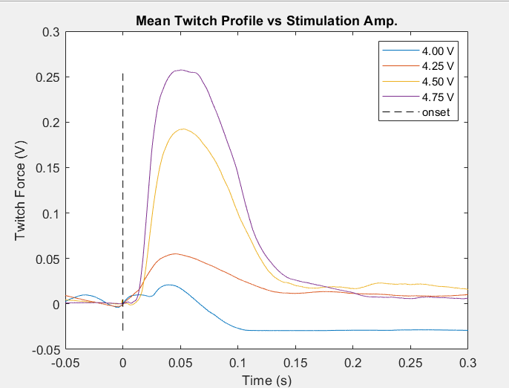

**Twitch Parameter vs Stimulation Amplitude**

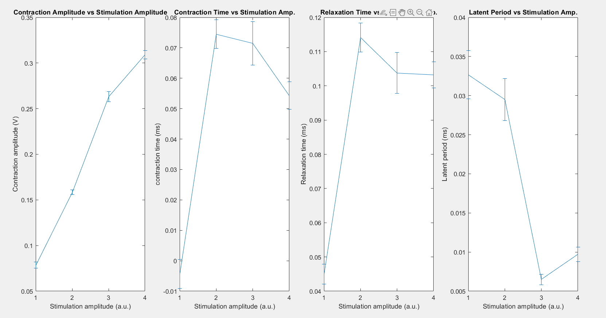

**Experiment 2**

**Twitch Amplitude and Force vs Stimulation Frequency**

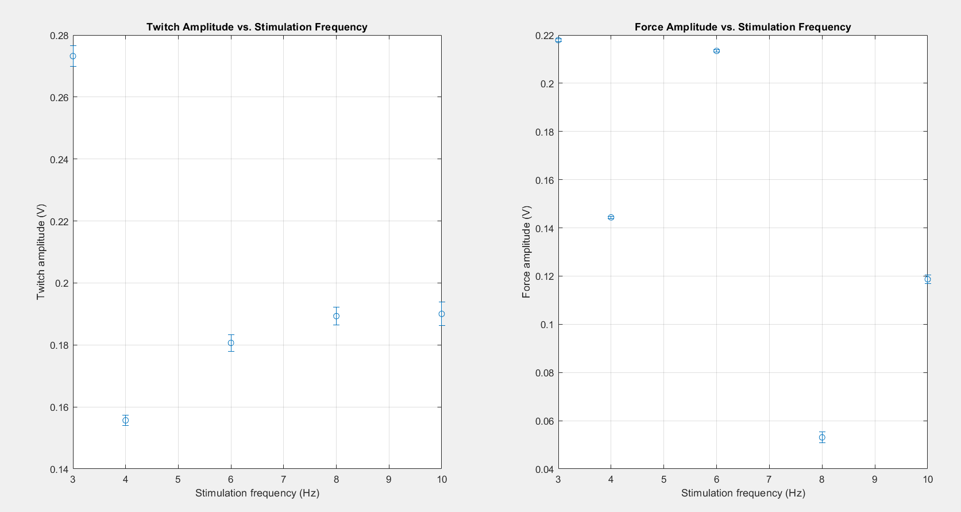

**Experiment 3**

**Raw Trial-Sorted EMG Traces**

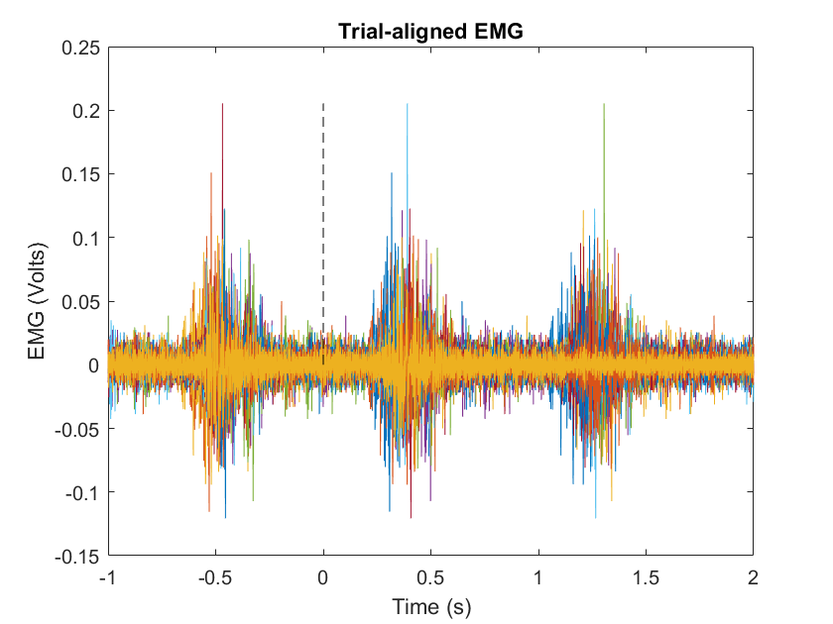

**EMG Feature vs Grip Force**

**(Raw EMG, RMS, Frequency bands of interest)**

